
Teacher:

Mr Staffe

Mrs. Carter

_____Mr Roohi

_____Ms Cheng

Test Five

Semester Two 2016
Year 12 Mathematics Methods
Calculator Assumed
Name:

- Complete all questions
- Show all necessary working
- Total Marks = 45
- 45 minutes

1. [2, 2, 2, 2 = 8 marks]

For each of the following samples, determine whether the sample is biased and if so, state the reason(s) for the bias.
(a) During an episode of The Biggest Loser, a weight loss show, the viewing audience were asked to SMS in either Yes or No to the following question: “Do you eat fastfood more than once a week?”

(b) A class of Year 8 students are asked to complete a compulsory survey for the following question: “Should the School reduce the lunch hour to 30 minutes?”

(c) A random sample of residents in a particular suburb were asked: “Do you prefer Hungry Jacks’ over other competitors?”

(d) Over the course of a Saturday, shoppers in the city central shopping mall were approached and asked: “Do you think the US response to the September 11 attacks was appropriate?”

2. [5 marks]
At the office of Dilsher/Karan, a company selling stationery supplies, there are the following number of employees:
1 Manager
7 Sales Representatives
2 Office Assistants
3 Accountants
13 Warehouse employees
The Manager, Jack Buildabridge, wants the Human Resources representative to survey 5 staff on the success of their Positivity Day.
If the Human Resources representative does this proportionally, how many of each staff group should he select? (Show all working – Not all groups need be represented)

3. [4, 3 = 7 marks]
(a) Given that about 15% of Australians are left handed, what is the probability that in a sample of 200 Australians, between 20 and 30 of them will be left handed? (Remember the continuity corrections).

(b) In 2010 a survey of Western Australians found 268 out of 327 people had completed Year 12. Use this to estimate the interval of probabilities that a Western Australian aged 20-24 had completed Year 12 within 1 standard deviation.

4. [1, 3, 1, 2, 2, 2 =11 marks]
On a Saturday night in Perth, a Random Breath Test (RBT) location is set up on a busy Perth street and 3000 RBTs are conducted by police. 45 drivers were found to have a blood alcohol limit in excess of 0.05.
(a) State the sample proportion of drivers with a blood alcohol concentration in excess of the limit of 0.05.

(b) Police conduct further RBTs in similar locations over the next 15 Saturday nights in Perth. Calculate the mean and standard deviation of the proportion of samples if each sample is 3000 drivers.

Police decide to conduct RBTs in this same location on a Sunday morning. They first decide
to model the scenario using a binomial random variable X.

(c) If each sample is to be of size 1000 on a Sunday morning, define the Random Variable X.

15 random samples are simulated and the results are given below.

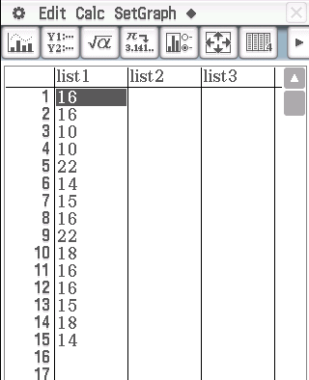
(d) Calculate the sample proportions from the simulations given above.

(e) Calculate the mean and standard deviation of the sample proportions.

(f) Comment on your answers to part (b) and (f).

5. [4, 3, 3 = 10 marks]
Giulia and Jesse run an icecream shop called Jessnjools and they’re wondering whether they should also sell coffee at their shop.
(a) Giulia thinks that the proportion of customers who would also buy coffee is 0.4. Calculate the size of the sample required for Giulia to achieve a margin of error 0f 3% in an approximate 95% confidence interval for this proportion.

(b) Jesse thinks that the proportion of customers who would also buy coffee is 0.5. Calculate the size of the sample required for Jesse to achieve a margin of error of 3% in an approximate 95% confidence interval for this proportion.

(c) What is the effect on the margin of error if Jesse is correct but they use the sample size from Giulia’s estimate?

6. [4 marks]
It is thought that about 60% of Year 12 students obtain their driver’s licence before they complete Year 12. How large a sample would be needed to establish this to within a margin of 5% at the 90% confidence level? (Show working for full marks)

Teacher:

Mr Staffe

Mrs. Carter

_____Mr Roohi

_____Ms Cheng

Test Five

Semester Two 2016
Year 12 Mathematics Methods
Calculator Assumed
Name: Mark King-Kee

- Total Marks = 45
- 45 minutes

1. [2, 2, 2, 2 = 8 marks]

For each of the following samples, determine whether the sample is bias and if so, state the reason(s) for the bias.

(a) During an episode of The Biggest Loser, a weight loss show, the viewing audience were asked to SMS in either Yes or No to the following question: “Do you eat fastfood more than once a week?”
Non response bias (Or any reasonable description)
(b) A class of Year 8 students are asked to complete a compulsory survey for the following question: “Should the School reduce the lunch hour to 30 minutes?”
Selection bias (Or any reasonable description)
(c) A random sample of residents in a particular suburb were asked: “Do you prefer Hungry Jacks’ over other competitors?”
Design bias and Selection bias (Or any reasonable description)
(d) Over the course of a Saturday, shoppers in the city central shopping mall were approached and asked: “Do you think the US response to the September 11 attacks was appropriate?”
Selection and Recall/Reporting bias (Or any reasonable description)

2. [5 marks]
At the office of Dilsher/Karan, a company selling stationery supplies, there are the following number of employees:
1 Manager
7 Sales Representatives
2 Office Assistants
3 Accountants
13 Warehouse employees
The Manager, Jack Buildabridge, wants the Human Resources representative to survey 5 staff on the success of their Positivity Day.
If the Human Resources representative does this proportionally, how many of each staff group should he select?
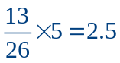
3 warehouse employees
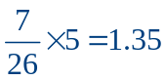
1 sales representative
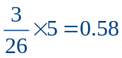
1 accountant
3. [4, 3 = 7 marks]
(a) Given that about 15% of Australians are left handed, what is the probability that in a sample of 200 Australians, between 20 and 30 of them will be left handed? (Remember the continuity corrections).
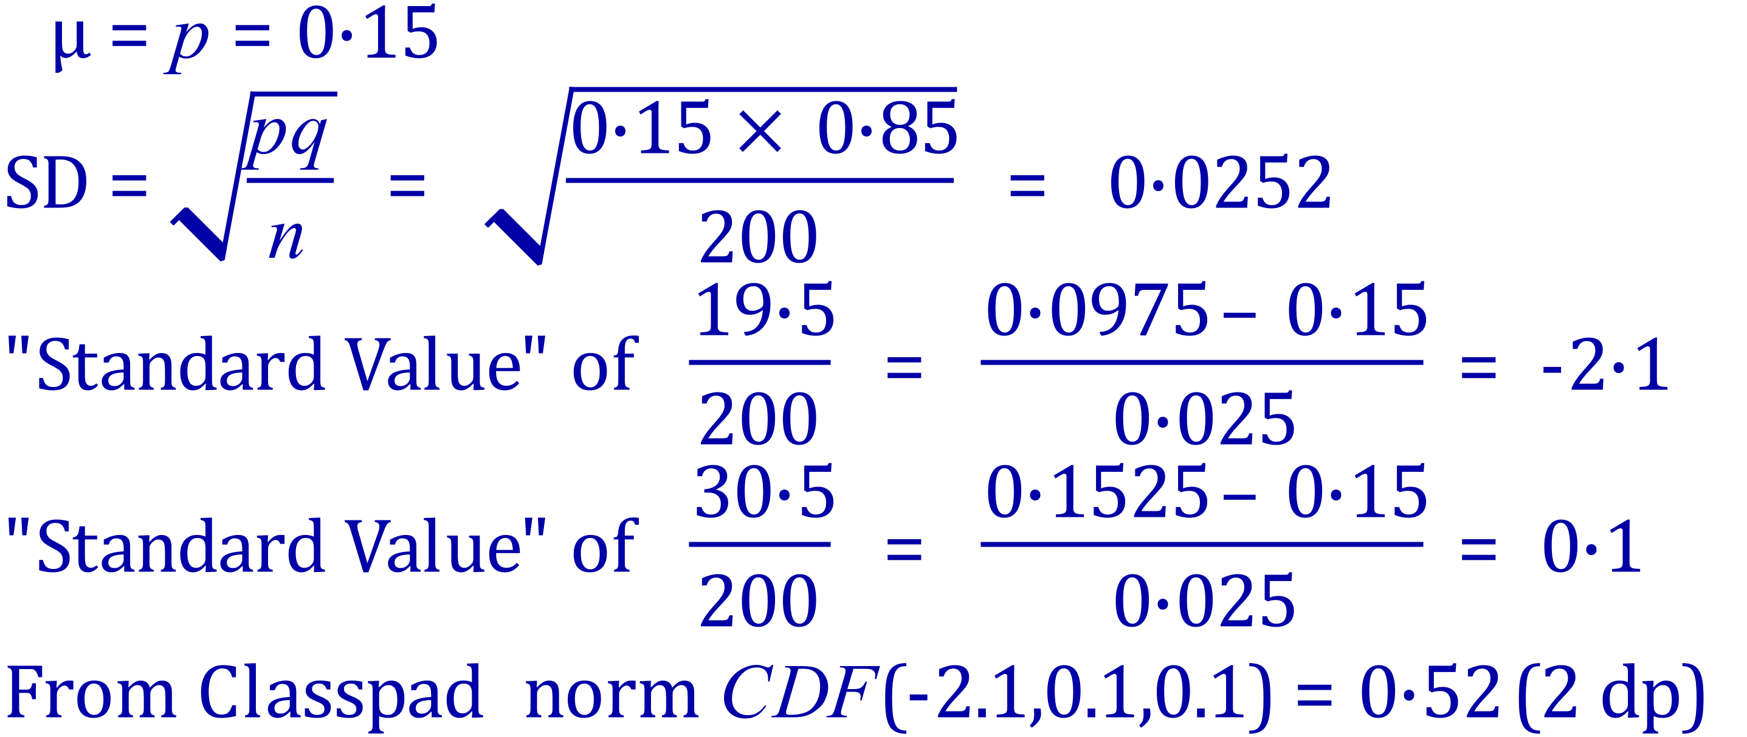
(b) In 2010 a survey of Western Australians found 268 out of 327 people had completed Year 12. Use this to estimate the interval of probabilities that a Western Australian aged 20-24 had completed Year 12 within 1 standard deviation. 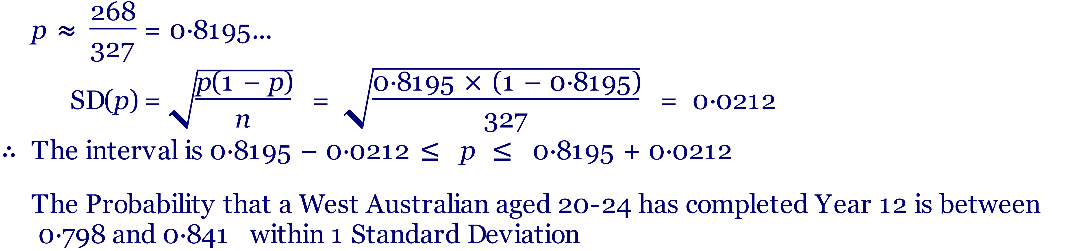
4. [1, 3, 1, 2, 2, 2 =11 marks]
On a Saturday night in Perth, a Random Breath Test (RBT) location is set up on a busy Perth street and 3000 RBTs are conducted by police. 45 drivers were found to have a blood alcohol limit in excess of 0.05.
(a) State the sample proportion of drivers with a blood alcohol concentration in excess of the limit of 0.05.
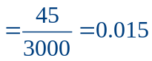
(b) Police conduct further RBTs in similar locations over the next 15 Saturday nights in Perth. Calculate the mean and standard deviation of the proportion of samples if each sample is 3000 drivers.
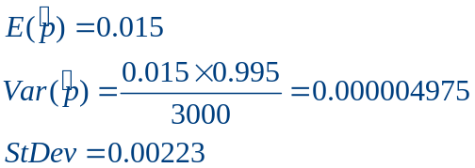
Police decide to conduct RBTs in this same location on a Sunday morning. They first decide to model the scenario using a binomial random variable X.

(c) If each sample is to be of size 1000 on a Sunday morning, define X.
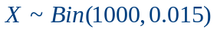

15 random samples are simulated and the results are given below.

(d) Calculate the sample proportions from the simulations given above.

(e) Calculate the mean and standard deviation of the sample proportions.
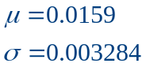

(f) Comment on your answers to part (b) and (e).
The mean and standard deviation of the proportion of samples in (b) is very close to the mean and standard deviation of the sample proportions.

5. [4, 3, 3 = 10 marks]
Giulia and Jesse run an icecream shop called Jessjewell and they’re wondering whether they should also sell coffee at their shop.
(a) Giulia thinks that the proportion of customers who would also buy coffee is 0.4. Calculate the size of the sample required for Giulia to achieve a margin of error 0f 3% in an approximate 95% confidence interval for this proportion.
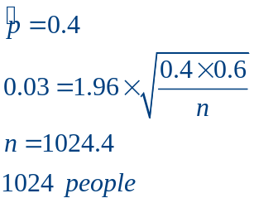
(b) Jesse thinks that the proportion of customers who would also buy coffee is 0.5. Calculate the size of the sample required for Jesse to achieve a margin of error of 3% in an approximate 95% confidence interval for this proportion.
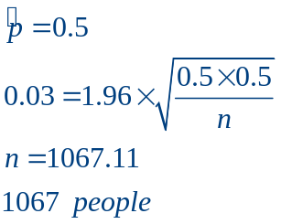
(c) What is the effect on the margin of error if Jesse is correct but they use the sample size from Giulia’s estimate?
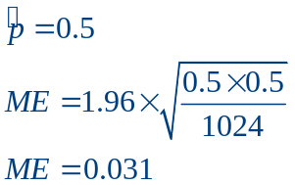
0.1% larger margin of error

6. [4 marks]
It is thought that about 60% of Year 12 students obtain their driver’s licence before they complete Year 12. How large a sample would be needed to establish this to within a margin of 5% at the 90% confidence level? (Show working for full marks)
